Reinstall firmware on the drone

1. Download and install mission planner (MP), if you haven’t already done so
2. Open MP
3. Plug the USB into the drone and the computer
4. Choose the correct com port (ie COM7) and the correct baud rate (115200) and hit connect in the upper right hand corner of MP
   1. Should look like “COM# PX4 FMU” in the drop down
5. If this doesn’t work then the firmware is screwed up!
6. Click on the “Initial Setup” tab on the top of MP
7. Click on the Wizard
8. Click on the drone highlighted in green, hit next
   1. 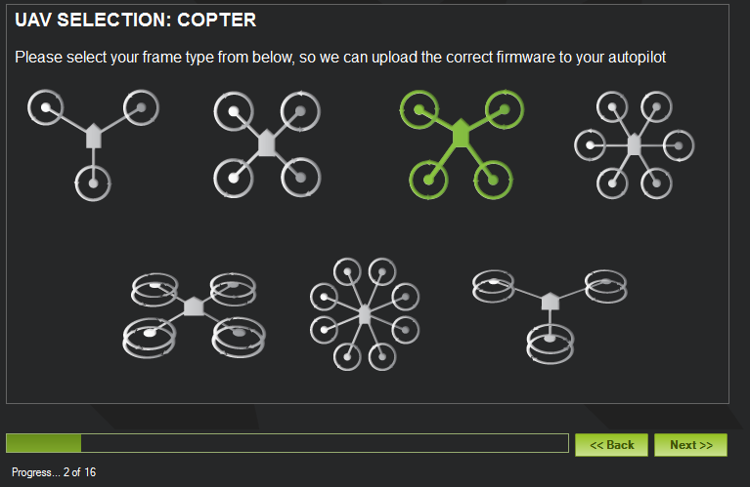
9. Select your com port; should look like “COM# PX4 FMU”, then hit next
10. Go through calibration steps
11. Go through compass calibration; watch youtube video
12. 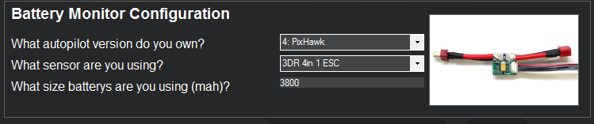
13. No sonar attachment
14. Make sure controller is controlling bars on screen; then click button to calibrate rc
15. Leave flight modes as is and hit next
16. Hit next, even if some stuff is red
17. Leave geofence as is
18. Should be done